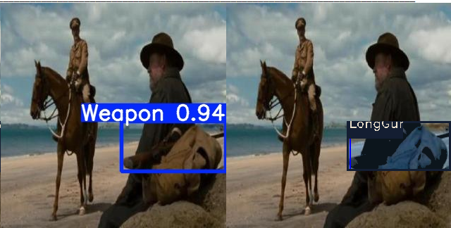 | LongGun
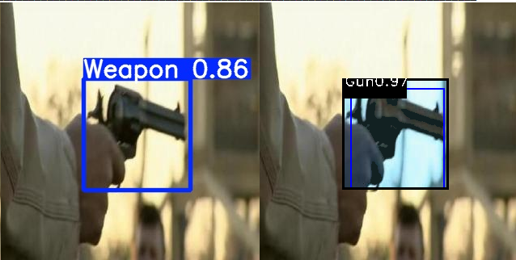 | Gun  & Enhance Localization
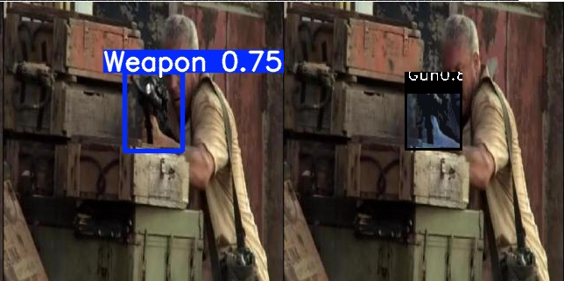 | Miss classify by 2nd stage
- Sample detections of proposed model on our “Weapon” dataset. We assume any missing classification is not counted as actual miss and is counted as weapon hit)

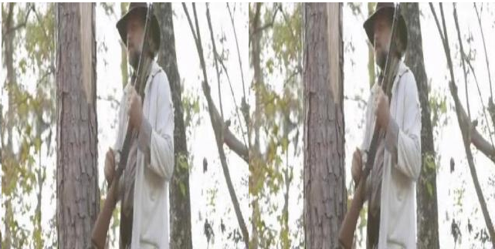 | YOLO missing detection
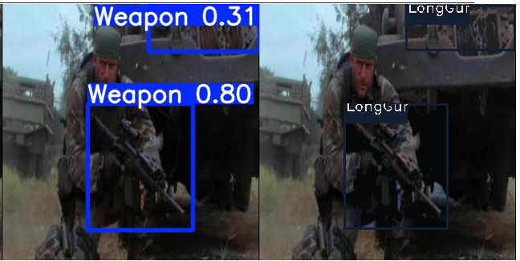 | Two stages false-positive (detection of confidence 0.31)
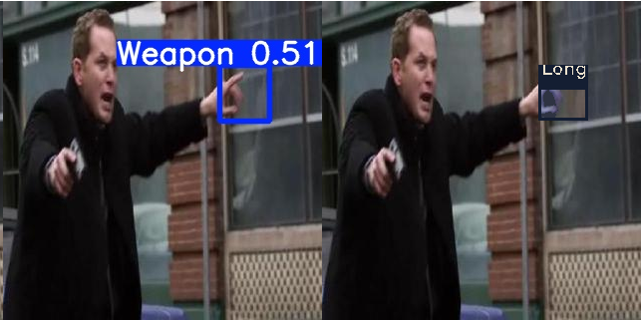 | YOLO missing and two stages false-positive
- Sample error patterns by proposed model on “weapon” dataset

